# EUSAIR YOUTH COUNCIL

# **Report on the Assessment and Selection of candidates for the EUSAIR Youth Council – EYC**

Contents

BACKGROUND 2

APPLICATION PROCESS REPORT 2

ASSESSMENT PROCESS REPORT 4

ELIGIBILITY CHECK 4

*Eligibility check results* 4

ASSESSMENT OF MOTIVATIONAL LETTERS 6

*Grading* 7

*Finalisation of Grading* 8

*Use of AI* 8

*Role of Facility Point Lead Partner EYC Coordinator* 8

*Motivational letter assessment results* 8

*Average score per question analysis* 9

SELECTION PROCESS REPORT 11

List of selected EYC candidates for EYC 2024 membership: 11

List of selected EYC reserve candidates for the EYC 2024 membership: 12

POSSIBLE NEXT STEPS TOWARDS EYC 2024 SET-UP 14

## BACKGROUND

The basic documents in which the assessment and selection of candidates for the EUSAIR Youth Council are defined are:

* the **EUSAIR Youth Council Concept Paper** approved through Governing Board Written Procedure on 9 April and
* **EUSAIR Youth Council Application pack** consolidated in Youth Council Task Force on 3 April 2024 and shared with National Coordinators after the Concept Paper written procedure, on 18 April 2024.

## APPLICATION PROCESS REPORT

The call for applications for the EUSAIR Youth Council was open from April 14 to May 27, 2024, on the Strategy's website. Accompanying the call was an extensive communication campaign on social media and direct outreach to our partners and other relevant stakeholders in the region, as well as a Youth Council event at the 9th EUSAIR Forum.

**The call attracted 185 applicants from all 10 EUSAIR participating countries. Below is the distribution by country:**

Most of the applicants come from urban areas, with only 48 coming from rural environments. The gender distribution is as follows: 98 identify as female, 85 identify as male, and 2 identify as non-binary or queer. The median age of the applicants is 25, while the average is 24.11 years.

**Do you currently live in rural or in urban environment?**

**Did you grow up in a rural or urban environment?**

**Gender**

**Age**

After the application period closed, candidates went through assessment.

## 

## ASSESSMENT PROCESS REPORT

The assessment process of candidates submitting applications for the EYC membership is defined in the EYC Concept Paper and EYC Application Pack. Its aim is to ensure fair, transparent, and consistent approach to evaluating applications for EYC membership.

### ELIGIBILITY CHECK

Agreed eligibility criteria according to which the eligibility check was performed by the Facility Point lead partner are the following:

1. The applicant has submitted the application within the deadline, all questions related to eligibility criteria are filled in as well as all answers in motivational letter are provided.
2. The applicant is a permanent resident of at least one of the EUSAIR participating country and region.
3. The applicant is aged between 18 and 29 years old (at the time of submitting the application).
4. The applicant possesses a proficiency level of at least B2 in English.
5. The applicant is not a member of EUSDR or EUSALP Youth Councils at the time of applying.
6. The Applicant is not a member of a political party and/or interest group.

### Eligibility check results

* 178 of applicants passed.
* 7 of applicants failed.

### Statistics after Eligibility check results

**Gender**

**Did you grow up in a rural or urban environment?**

**In which EUSAIR participating country/region is your permanent residency?**

**Do you currently live in rural or in urban environment?**

Main reasons for failing the eligibility check were:

* No written birthday dates.
* Knowledge of English bellow B2.

### ASSESSMENT OF MOTIVATIONAL LETTERS

According to the EYC Application Pack the purpose of the motivational questions was to check the candidates’ motivation, understanding of the region's challenges, their constituency among the youth in their country/Adriatic-Ionian region and their vision for the future.

The applicants successfully passing the eligibility check were divided into 11 groups ranging from 15 to 19 applicants in each group. The group documents were assigned to 11 assessors from the EUSAIR Facility Point and its partners, as well as one person from the European Commission.

**It was ensured that assessors were not assessing candidates from their own country. Each candidate was assessed twice.**

To ensure consistency in scoring, all assessors attended **introductory sessions with tutorial** in June and July 2024 before they started assessing, where they received detailed instructions on how to conduct the assessments.

An EYC coordinator was assigned at the Facility Point Lead Partner to lead the process, ensure its consistency and to assist assessors with any further explanations, if needed.

The assessments were conducted on Google Forms, the form was prepared by the EUSAIR Facility Point Lead Partner.

All assessors finished their assessments within the agreed deadline, 15 August 2024.

### Grading

**Each candidate was graded twice**, with each assessment being conducted independently to maintain objectivity.

The documents provided to assessors were **anonymized** to prevent any potential bias, containing only the Application ID, basic information such as location, selected topics, education, and the responses to motivational questions.

Applications were then graded on a scale from 0 to 3, based on the following criteria (from the Application Pack):

|  |  |
| --- | --- |
| 3 | ***Good*** – the section of the application is clear and provides clear and coherent information. |
| 2 | ***Satisfactory*** - the section of the application is sufficiently clear and contains minor shortcomings. |
| 1 | ***Poor*** - the section of the application is of low quality. |
| 0 | ***Insufficient***- the section of the application analysed does not meet the requirement/the information is not present. |

While grading the answers the accessor used the following guiding questions (defined in the EYC Application Pack).

* *Relevance: Does the response directly address the question?*
* *Insightfulness: Does the candidate demonstrate a deep understanding of the issues or a unique perspective?*
* *Passion and Motivation: Does the candidate convey genuine interest and enthusiasm for the council's mission?*
* *Clarity and Coherence: Is the response well-organized and clearly articulated?*
* *Vision and Creativity: Does the candidate show innovative thinking and a clear vision for their role and the council's future?*

Assessors were provided with a detailed scoring rubric to minimize subjective interpretations. The assessors provided written explanations for the chosen grades, to explain the reason behind the points given.

The methodology in the Application Pack further says that the candidate should reach an average score of at least 1 in all criteria.

Assessors received two batches of applications from the Facility Point Lead Partner, where none of the candidates were from the assessor’s country.

### Finalisation of Grading

To get the final score for each applicant, an average score was calculated.

The Facility Point Lead Partner checked the assessments until the end of August 2024. In case there were **discrepancies between the two assessors' ratings** (difference of 2 points or more per question - e.g., a rating of 1 vs. 3 or 0 vs. 2), the two evaluators met to discuss and determine the final appropriate rating. If any motivational question was graded as 0 by both assessors, the applicant was automatically disqualified. These **consolidation meetings** took place until 9 September 2024.

#### Use of AI

Applications where responses showed clear evidence of AI use without significant original input from the applicant were graded 0.

### Role of Facility Point Lead Partner EYC Coordinator

The EYC coordinator at the Facility Point Lead Partner followed and monitored the application and assessment process. The person checked the work of the assessor and set up meetings so that all criteria was followed, and the assessors remained as objective as possible. The coordinator also checked all the applications and prepared all the materials used for the assessment.

### Motivational letter assessment results

According to the methodology agreed in the Application Pack, **candidates were assessed based on the total score they received across all questions.** **To pass, the candidate should reach an average total score of at least 6,00 points out of the maximum 12 points available.**

The logic behind this threshold was that the final selection, carried out by the algorithm, should be done only among the candidates reaching a certain quality in answering 4 motivational questions – proving their motivation, understanding of the region's challenges, their constituency among the youth in their country/Adriatic-Ionian region and their vision for the future.

Below is a table where we analysed the scores according to the resident country.

|  |  |  |  |
| --- | --- | --- | --- |
| **COUNTRY** | **N PASS OVER TRESHOLD** | **N DID NOT PASS OVER TRESHOLD** | **AVERAGE NUMBER OF POINTS** |
| Albania | 27 | 6 | 8 |
| Bosnia and Herzegovina | 19 | 1 | 8,4 |
| Hellenic Republic (Greece) | 13 | 4 | 8,5 |
| Croatia | 5 | 1 | 8,3 |
| Italy (only EUSAIR participating regions) | 51 | 6 | 8,4 |
| Montenegro | 12 | 1 | 9 |
| North Macedonia | 7 | 1 | 8,3 |
| Serbia | 11 | 3 | 8 |
| Slovenia | 5 | 0 | 9,5 |
| San Marino | 5 | 0 | 9,4 |
| **TOTAL** | **155** | **23** | **8,58** |

### Average score per question analysis

Bellow you can find the percentage of different points awarded per question.

1. ***What are your long-term personal and professional goals, and how does being a part of the EUSAIR Youth Council align with these aspirations?***

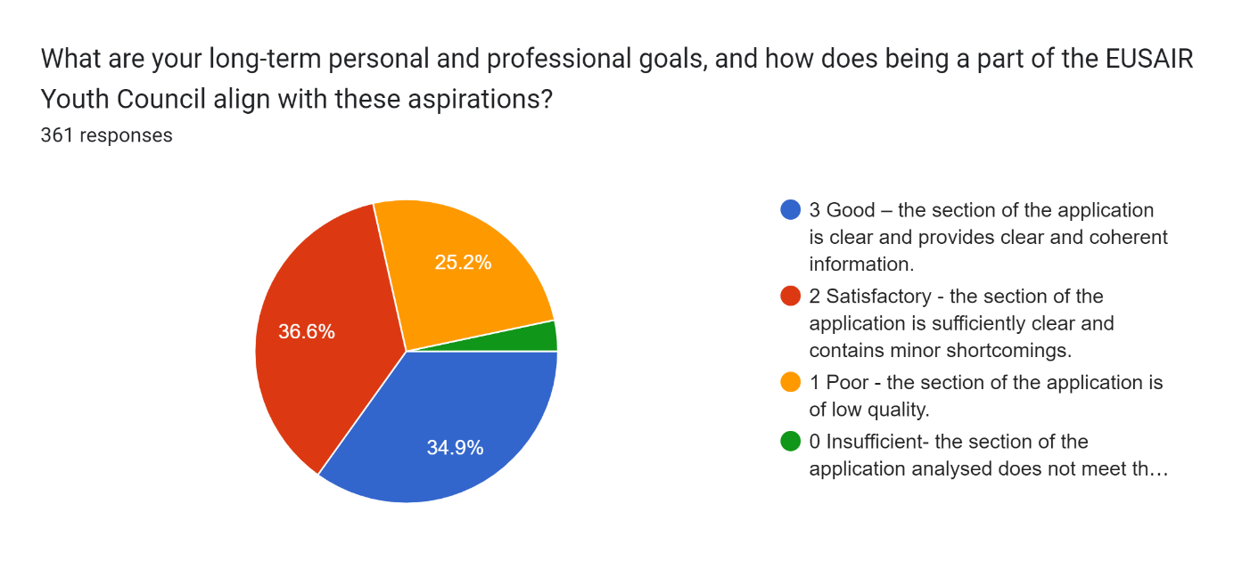

1. ***What unique perspectives or experiences do you bring to the EUSAIR Youth Council, especially considering your background***? ***What skills and experiences do you possess that make you a suitable candidate for the EUSAIR Youth Council?***

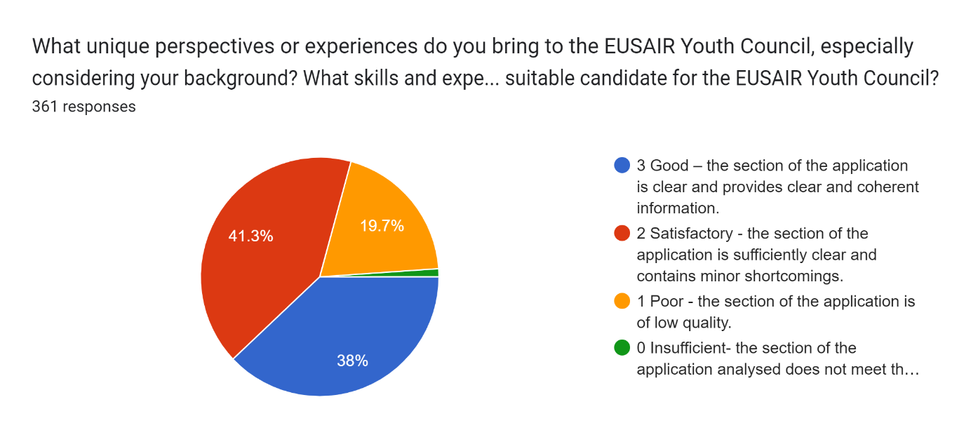

1. ***Are you active in any youth or other civil society organisation or network****(could be from any field of interest, not just active citizenship, but also sports, culture, hobby…)****? Do you have the possibility to reach out to young people in the region or to youth or other civil society organisations and networks and in what way?***

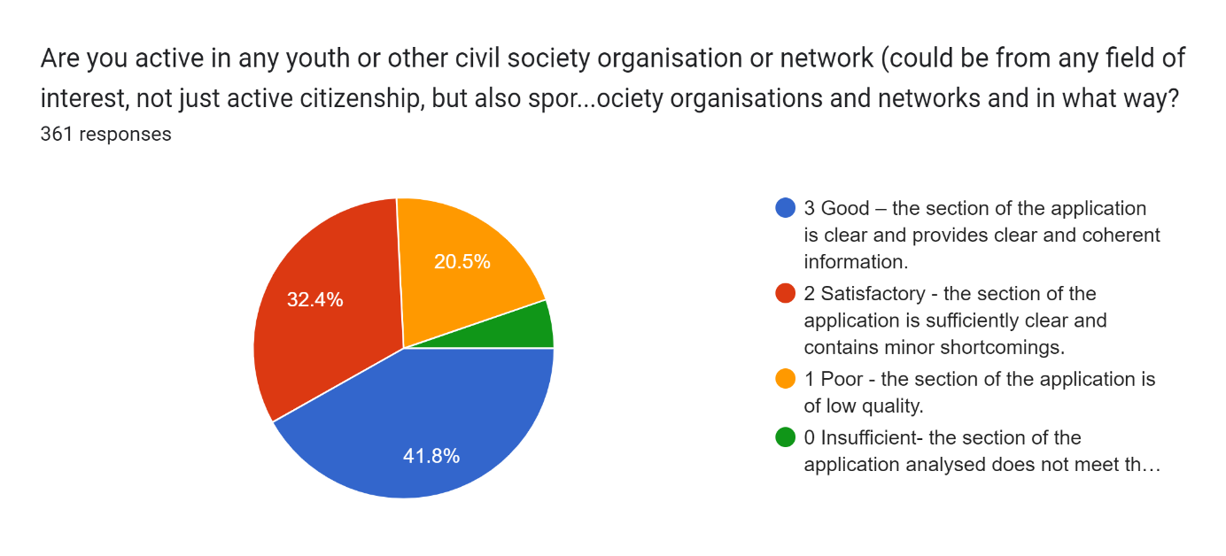

1. ***Describe a challenge faced in the Adriatic and Ionian region that you are passionate about. How would you propose to address it through the EUSAIR Youth Council?***

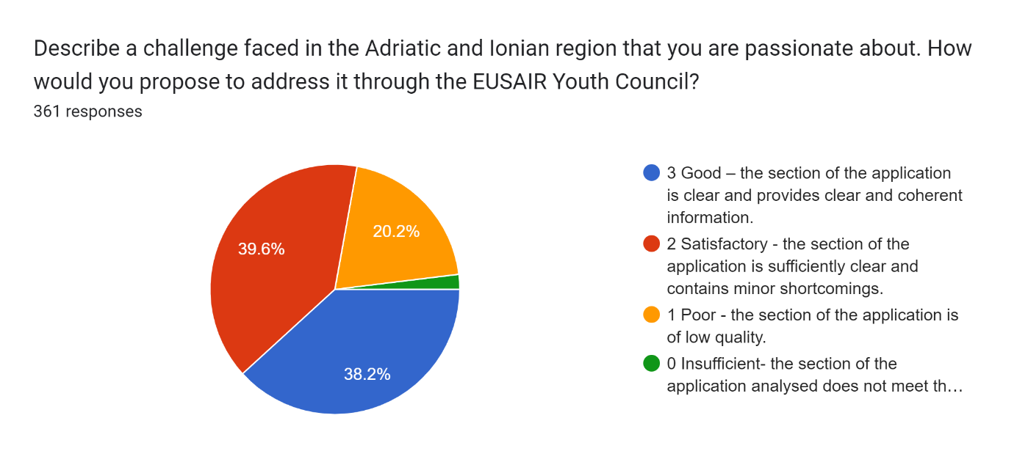

The average score for each question is as follows:

* Question number 1: 2,04
* Question number 2: 2,17
* Question number 3: 2,10
* Question number 4: 2,16

This gives us an insight that the candidates mostly scored higher than grade two per question, meaning that the pool of candidates we had overall proved to be high quality. The average total points that all the applicants had was 8,58.

The reason for receiving 0 points varied. Mostly they were awarded because of incomplete motivational letter questions, heavy use of Artificial Intelligence or did not affectively address the questions at hand.

## SELECTION PROCESS REPORT

According to the EYC Concept Paper if many applications are received, random selection with the help of the **algorithm** is to be applied. The number of applicants was high (more than 2 eligible and quality applicants from each country), therefore the use of algorithm was applied.

The Algorithm works by performing a specific task given to it: selecting two candidates per country, ensuring gender balance, urban or rural residency, thematic interest and age as far as possible. This is done by putting all of the possible candidates who have reached the **threshold of 6 points** into an excel file and getting the first batch of 20 candidates. All the rest were put into a new file and were put through the process again, to prepare the reserve list.

A list of 20 candidates was selected, additionally, a reserve list of 20 candidates, with two reserve candidates per country was also created.

### List of selected EYC candidates for EYC 2024 membership:

|  |  |  |  |  |  |  |
| --- | --- | --- | --- | --- | --- | --- |
| **Name** | **Name (Last)** | **Date** | **Gender** | **Country** | **Location** | **Topics** |
| Altin | Guberi | 29 | Male | AL | Rural | Blue And Green Technologies,  Multimodal Connectivity,  Youth Engagement and Employment |
| Melpomeni | Nelaj | 30 (BD after the start of application proccess) | Female | AL | Urban | Multimodal Connectivity, Urban Nodes, Research and Innovation |
| Adnan | Solak | 22 | Male | BA | Urban | Preparing for the Future: Knowledge, Skills, and Management,  Social Innovations, EU Enlargement |
| Anastasija | Katić | 19 | Female | BA | Urban | Green Energy, Preparing for the Future: Knowledge, Skills, and Management, Youth Engagement and Employment |
| Gerasimos | Avgerinos | 21 | Male | EL | Urban | Fisheries And Aquaculture, Marine and Coastal Environment, Capacity Building |
| Marianna | Peiou | 19 | Female | EL | Urban | Blue And Green Technologies, Facilitating Digital and Green Transition of The Tourism and Cultural Heritage Offer, Preparing for the Future: Knowledge, Skills, and Management |
| Antonio | Grujevski | 28 | Male | HR | Urban | Marine And Coastal Environment, Transnational Terrestrial Habitats and Biodiversity, Facilitating Digital and Green Transition of The Tourism and Cultural Heritage Offer |
| Lara | Šare | 18 | Female | HR | Urban | Marine And Coastal Environment, Social Innovations |
| Alessandro | Bosco | 27 | Male | IT | Urban | Blue And Green Technologies, Maritime Transport, Social Innovations |
| Luisa | Centonze | 27 | Female | IT | Urban | Urban Nodes, Facilitating Digital and Green Transition of The Tourism and Cultural Heritage Offer, Preparing for the Future: Knowledge, Skills, and Management |
| Vladimir | Perazić | 23 | Male | ME | Urban | Youth Engagement and Employment, EU Enlargement, Digitalisation |
| Lejla | Hadžijusufović | 25 | Female | ME | Rural | Preparing for the Future: Knowledge, Skills, and Management, Social Innovations, Digitalisation |
| Blendi | Hodai | 22 | Male | MK | Urban | EU Enlargement, Capacity Building, Digitalisation |
| Ankica | Sokolic | 24 | Female | MK | Urban | Energy Networks, Green Energy, Youth Engagement and Employment |
| Petar | Stevanović | 23 | Male | RS | Urban | Preparing for the Future: Knowledge, Skills, and Management, Social Innovations, Research and Innovation |
| Milica | Stankić | 24 | Female | RS | Urban | Facilitating Digital and Green Transition of The Tourism and Cultural Heritage Offer, Youth Engagement and Employment, EU Enlargement |
| Petar | Mrdović | 25 | Male | SI | Rural | Youth Engagement and Employment, EU Enlargement, Digitalisation |
| Andrea | Damjanović | 21 | Female | SI | Urban | Urban Nodes, Preparing for the Future: Knowledge, Skills, and Management, Decent Work and Gender Equality |
| Francesco | Moroni | 27 | Male | SM | Urban | Green Energy, Facilitating Digital and Green Transition of The Tourism and Cultural Heritage Offer, Preparing for the Future: Knowledge, Skills, and Management |
| Lia | Gasperoni | 24 | Female | SM | Rural | EU Enlargement, Circular Economy, Green Rural Development |

### List of selected EYC reserve candidates for the EYC 2024 membership:

|  |  |  |  |  |  |  |
| --- | --- | --- | --- | --- | --- | --- |
| **Name** | **Name (Last)** | **Date** | **Gender** | **Country** | **Location** | **Topics** |
| Klajdi | Kaziu | 27 | Male | AL | Urban | Youth Engagement and Employment, Promoting Skills Acquisition for Future Labour Markets , Decent Work and Gender Equality |
| Marina | Rrika | 25 | Female | AL | Urban | Youth Engagement and Employment, Decent Work and Gender Equality, EU Enlargement |
| Njegos | Pantic | 22 | Male | BA | Urban | Youth Engagement and Employment, Social Innovations, EU Enlargement |
| Maja | Ibričić | 23 | Female | BA | Urban | Energy Networks, Green Energy, Preparing for the Future: Knowledge, Skills, and Management |
| Georgios | Kapasakalis | 29 | Male | EL | Urban | Urban Nodes, Energy Networks, Green Energy |
| Georgia Maria | Patsi | 19 | Female | EL | Urban | Facilitating Digital and Green Transition of The Tourism and Cultural Heritage Offer, Decent Work and Gender Equality, Social Innovations |
| Ana | Krošl | 23 | Female | HR | Urban | Preparing for the Future: Knowledge, Skills, and Management,Youth Engagement and Employment, Promoting Skills Acquisition for Future Labour Markets |
| Ana | Puljić | 24 | Female | HR | Rural | Youth Engagement and Employment, Research and Innovation, Circular Economy |
| Alberto | Tarantino | 22 | Male | IT | Urban | Energy Networks, EU Enlargement, Circular Economy |
| Antonella | Iaffaldano | 22 | Female | IT | Urban | Facilitating Digital and Green Transition of The Tourism and Cultural Heritage Offer, Youth Engagement and Employment, Decent Work and Gender Equality |
| Aldo | Vlahovljak | 26 | Male | ME | Urban | Facilitating Digital and Green Transition of The Tourism and Cultural Heritage Offer, Preparing for the Future: Knowledge, Skills, and Management, Green Rural Development |
| Mina | Milović | 24 | Female | ME | Urban | Youth Engagement and Employment, EU Enlargement, Capacity Building |
| Ivan | Durgutov | 29 | Male | MK | Urban | Youth Engagement and Employment, Promoting Skills Acquisition for Future Labour Markets, Decent Work and Gender Equality |
| Hristijan | Ilievski | 27 | Male | MK | Rural | Preparing for the Future: Knowledge, Skills, and Management, Youth Engagement and Employment, EU Enlargement |
| Andrija | Planić | 24 | Male | RS | Urban | Urban Nodes, Facilitating Digital and Green Transition of The Tourism and Cultural Heritage Offer, Youth Engagement and Employment |
| Jovana | Milurović | 21 | Female | RS | Urban | Youth Engagement and Employment, Capacity Building, Green Rural Development |
| Rok | Učakar Grašič | 23 | Male | SI | Rural | Youth Engagement and Employment, EU Enlargement, Circular Economy |
| Amadej | Petan | 26 | Male | SI | Rural | Youth Engagement and Employment, EU Enlargement, Circular Economy |
| Maria Eleonora | Vaglio | 25 | Female | SM | Urban | Preparing for the Future: Knowledge, Skills, and Management, Youth Engagement and Employment, EU Enlargement |
| Matilde | Dani | 25 | Female | SM | Urban | Preparing for the Future: Knowledge, Skills, and Management, EU Enlargement, Research and Innovation |

## POSSIBLE NEXT STEPS TOWARDS EYC 2024 SET-UP

|  |  |
| --- | --- |
| **Task** | **Time** |
| End of Consolidation period | AUGUST 15 - SEPTEMBER 9 |
| List of 20 selected members and 20 reserve members | SEPTEMBER 10 |
| 9th TASK FORCE meeting | SEPTEMBER 11 |
| Written Procedure for approval of the list by the Governing Board | 12-19 SEPTEMBER |
| Notification letters sent to selected candidates (with letter of commitment to be signed) | 23 SEPTEMBER |
| Final list of committed members. | 7 OCTOBER |
| Online meeting with EYC members regarding next steps and organisation of the inauguration meeting & contacting those who were not selected | MID OCTOBER |
| Inauguration meeting of EUSAIR Youth Council Members with capacity building in Croatia | END OF NOVEMBER/TBD |
| PUBLIC INNAUGURATION EVENT in Greece | FEB/MARCH 2025/TBD |