***24th GOVERNING BOARD MEETING of the European Union Strategy for the Adriatic and Ionian Region (EUSAIR) and back-to-back meetings***

*Patras (Greece), 12-13 February 2025*

***Logistic information to help you arrange your travel and accommodation.***

**Registration**

Participants are kindly requested to complete the Registration form on the following link: <https://www.adriatic-ionian.eu/registration-form-for-the-24th-eusair-governing-board-and-its-back-to-back-meetings-patras-greece/> **until 27 January 2025.**

**Transfers between Athens International Airport and Patras will be organised on 11 and 14 February 2025**

|  |
| --- |
| **Transfer from the Athens International Airport to Patras:**  On 11 February 2025 two buses will depart from El. Venizelos Airport to the city of Patras. Departure times will be determined after the registration deadline, for the best service to all travellers. Departure times and exact location will be communicated in due time.  **Transfer from Patras to the Athens International Airport:**  On 14 February 2025 two buses will depart from the city of Patras to El. Venizelos Airport. Departure times will be determined after the registration deadline, for the best service to all travellers. Departure times and exact location will be communicated in due time. |

**Public transport to reach Patras in alternative case**

|  |
| --- |
| **By bus from Athens to Patras**  **X93: Airport - Kifissos Ave. Overground Station (express)**  General: The buses of the X93 line depart from the Arrivals area of El. Venizelos every approximately 30-40 minutes. The duration of the route is approximately 60 minutes. The bus passes through Attiki Odos, Nea Filadelfia and ends at Kifissos KTEL. Below you will find the departure times from the airport and the stops the bus makes for boarding.  Starting point: Arrivals level, bus stop between Exits 4 and 5  *Departure times from El. Venizelos*  00:25, 01:15, 02:00, 02:45  03:30, 04:15, 05:15  06:05, 06:40, 07:15, 07:45, 08:10, 08:35  09:00, 09:30, 10:00, 10:30, 11:00, 11:30  12:00, 12:30, 12:55, 13:25, 13:55, 14:25, 14:55  15:30, 16:05, 16:35, 17:05, 17:40  18:15, 18:50, 19:15, 19:45, 20:15, 20:50  21:25, 22:10, 22:55, 23:40  Schedule stops  EL. VENIZELOS-ARRIVALS  EPM/KO AIRPORT PARK  ADMINISTRATION BUILDING  ATTICA ROUTES  SEA  KIFISIAS  NEA PHILADELPHIA INTERCHANGE  LIOSION HIGHWAY STATION  ROSSINIOL  KOLOKYNTHOUS  KIFISOS HIGHWAY STATION  *Departure times from KFISSOS Bus Station - El. Venizelos*  05:57, 06:47, 07:17, 07:47, 08:12, 08:42, 09:07, 09:47,  10:22, 10:57, 11:32, 12:07, 12:37, 13:02, 13:27, 13:57  14:27, 14:52, 15:22, 15:47, 16:17, 16:47, 17:12, 17:47  18:17, 18:57, 19:32, 20:02, 20:37, 21:02, 21:37, 22:07  22:52, 23:37, 24H+00:22, 24H+01:12  **The Athens-Patras KTEL** routes start from 7:00 in the morning until 22:00, some are Express and the journey lasts 2.5 hours and those that are not Express last 3 hours (it has 4-5 stops in between).  **The Patras-Athens KTEL** routes start from 6:30 in the morning until 21:00 and there is also a night one at 02:30. The Patras KTEL is located in a central location near the old port next to the My Way hotel.  At the following link the routes can be find:  <https://www.ktelachaias.gr/%ce%b4%cf%81%ce%bf%ce%bc%ce%bf%ce%bb%cf%8c%ce%b3%ce%b9%ce%b1/>  **By train from Patras airport**  The information about transfer from the Patras airport to Patras are available at the following websites:   * <https://www.patrasinfo.com/%CF%83%CF%84%CE%B7%CE%BD-%CF%80%CE%AC%CF%84%CF%81%CE%B1-%CE%BC%CE%B5-%CE%BF%CF%83%CE%B5/> * <https://www.hellenictrain.gr/>   The train station in Patras is located in a central location near the old port, opposite Trion Symmachon square and close to the Patras KTEL. |

**Meetings Venue**

**The meetings on 12th and 13th February 2025** **will take place at the Regional Council hall of Western Greece, N.E.O. Patron-Athinon 32, Patras (**[**see on map**](https://www.google.com/maps/place/%CE%91%CE%AF%CE%B8%CE%BF%CF%85%CF%83%CE%B1+%CE%A0%CE%B5%CF%81%CE%B9%CF%86%CE%B5%CF%81%CE%B5%CE%B9%CE%B1%CE%BA%CE%BF%CF%8D+%CE%A3%CF%85%CE%BC%CE%B2%CE%BF%CF%85%CE%BB%CE%AF%CE%BF%CF%85+%CE%94%CF%85%CF%84%CE%B9%CE%BA%CE%AE%CF%82+%CE%95%CE%BB%CE%BB%CE%AC%CE%B4%CE%B1%CF%82/@38.2596709,21.7538282,16z/data=!4m10!1m2!2m1!1sregional+council+patras!3m6!1s0x135e497159633569:0x307d004b996a91f3!8m2!3d38.261374!4d21.750294!15sChdyZWdpb25hbCBjb3VuY2lsIHBhdHJhc5IBEHJlZ2lvbmFsX2NvdW5jaWzgAQA!16s%2Fg%2F11mp8b3_2q?entry=ttu&g_ep=EgoyMDI1MDEyMC4wIKXMDSoASAFQAw%3D%3D)**)**

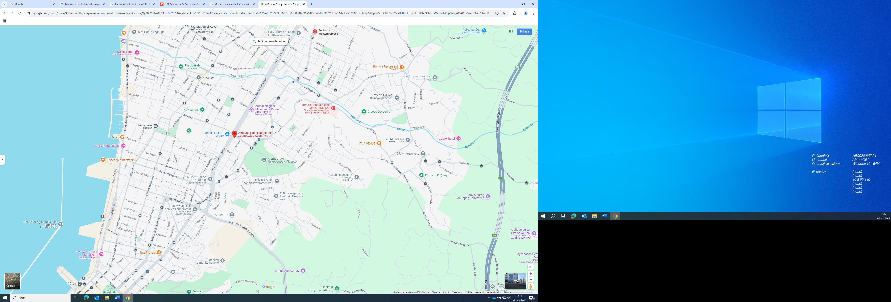

Since there is no public transport to serve, there will be a bus organised between the below recommended hotels and the meetings venue. The exact times and departure/return points will be communicated in due time.

**Accommodation – Recommended hotels:**

|  |  |
| --- | --- |
| **Moxy Patra Marina**  **A:**  Moxy Patra Marina, Iroon Polytechniou Av. & Kyprou St. 58, 26441 Patra, Greece  **W:** https://www.marriott.com/en-us/hotels/gpaox-moxy-patra-marina/overview/?scid=f2ae0541-1279-4f24-b197-a979c79310b0  **T:** +302614409400 | **Price per day:**  Single room city view: 78 €  Double room city view: 88 €  Single room sea view: 98 €  Double room sea view: 108 € |
| **City Loft Patras 3\***  **A:** City Loft Patras, Valtetsiou 4, Achaea, 26223 Patras, Greece,  **W:** <https://cityloft.gr/>  **T**: [+302610223552](tel:+302610223552) | Single room**:** 75 € |
| **My Way Hotel 4\***  **A:** My Way Hotel, Othonos Amalias Avenue 16, Patras 262 23, Greece  **W:** https://www.mywayhotel.gr/home  **T:** [+30 2610 623 131](tel:+302610623131) | Standard single room (city view): 70 €  Standard double room (city view): 80 €  Superior single room (sea view): 84 €  Superior double room (sea view): 95 €  Superior triple room (sea view): 129 € |

The tourist tax is not included in the prices and is from 1.50 to 3.00 €, depending on the hotel.

Some rooms were prebooked in above listed hotels. Please refer to “*EUSAIR*” or the “*Ministry of National Economy and Finance*” when booking the accommodation.

**Social Dinner on 12 February 2025**

On 12th February 2025 there will a social dinner organized for the participants and offered by the Region of Western Greece.

At 19:30 (local time) a bus will depart from the My Way Hotel, with the aim of transporting everyone to the W restaurant (Rio). The transfer is also offered by the Region of Western Greece.

**Site visit and lunch during GB meeting on 13 February 2025**

A site visit to the Achaia Clauss ([see on map](https://www.google.com/maps/place/Achaia+Clauss/@38.1954086,21.7652039,4797m/data=!3m1!1e3!4m6!3m5!1s0x135e35d1839f7cd5:0x98948350780342be!8m2!3d38.1969276!4d21.7696758!16zL20vMGdyOWx6?entry=ttu&g_ep=EgoyMDI1MDEyMC4wIKXMDSoASAFQAw%3D%3D)) premises will take place with the relevant wine tasting, which will be provided by the Region of Western Greece. Transportation will be organised.

**Practical information**

* **Local currency:** Euro (EUR).
* **Time zone:** Eastern European Time (EEST), UTC +2.
* Banks are open from 8 AM to 2 PM, Monday to Friday. ATMs are widely available around the city. Most shops accept major credit cards.
* **Weather:** the temperature ranges between 6°C and 14°C degrees during the February.
* **Medical services:** Patras has a 24h Emergency health centre (primary care services). Medical insurance is to be arranged by participants.
* **Tourist information:** <https://www.visitgreece.gr/mainland/peloponnese/patras/>

Slika, ki vsebuje besede na prostem, nebo, vozilo, voda

Opis je samodejno ustvarjen

*Source: Pixabay*

*For any additional support regarding logistic you may contact:*

[*eusair-fp.gr@mou.gr*](mailto:eusair-fp.gr@mou.gr)