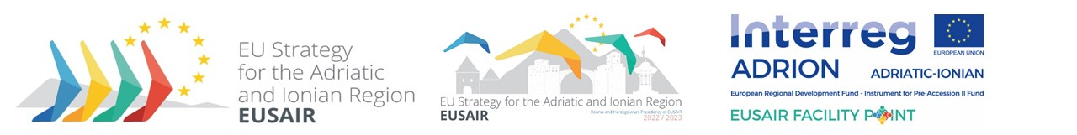

3rd EUSAIR Revision Working Group meeting
11th May 2023

Venue - Hotel Courtyard by Marriott Sarajevo, Skenderija 1, Sarajevo, Bosnia and Herzegovina

Participants
Members of EUSAIR Revision Working Group, as nominated by the participating countries and European Commission, EUSAIR Facility Point Lead Partner and external experts

Chair and facilitator
EUSAIR Presidency, Midhat Džemić

Accommodation arrangements – Hotel Courtyard by Marriott Sarajevo

Dinner on 10 May, 19:30 - Konoba Luka Sarajevo, Obala Maka Dizdara 8

DRAFT AGENDA

11 May 2023
8:30-9:00 | Registration
09:00-09:15 | - Introduction  (EUSAIR Presidency, hosts)
09:15-09:30 | - Overview of the Action Plan revision process  (EUSAIR Facility Point Lead Partner presents the status)
9:30-10:15 | - Presentation of report from social pillar workshop  (overview of results and inputs by Croatia)
10:15-10:30 | - Presentation of proposal for Pillar 1  (presentation)
10:30-11:30 | - Follow-up to the 19th GB Meeting (Continuation) – agreement on new EUSAIR thematics  (discussion, agreement on new thematics to be proposed to the GB for adoption, discussion on how to implement new thematics)
11:30-11:45 | Coffee break
11:45-14:00 | - Continuation of Agenda Item 5
14:00-14:15 | - A.O.B.
14:15 – 14:30 | - Conclusions
14:30 | Informal networking lunch and departures

