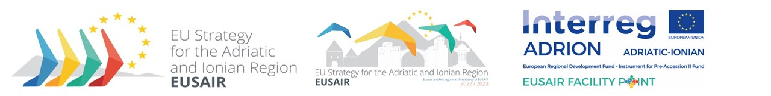

2nd EUSAIR Revision Working Group meeting
24th February 2023

Venue: Athens (Greece) – Stavros Niarchos Foundation Cultural Center, Syggrou Avenue 364, 17674 Kallithea, Google Map Directions
VIP & Donors Lounge, 1st floor, National Greek Opera

Access: For convenient access to and from the SNFCC, transportation by shuttle bus is available daily to visitors, free of charge. A minibus bearing the SNFCC logo departs from Syntagma, makes a stop at Syggrou-Fix Metro station (Syggrou Avenue), and arrives at the south side of the SNFCC Canal (near the GNO building) and vice versa. The starting point of the shuttle bus is located at the Bus station, near the junction of Syntagma Square with Ermou. More information and timetable here.
The meeting is planned in person.

Participants
Members of EUSAIR Revision Working Group, as nominated by the participating countries and European Commission, EUSAIR Facility Point Lead Partner and external experts

Chair and facilitator
EUSAIR Presidency, Midhat Džemić

Accommodation arrangements:
TITANIA HOTEL ATHENS, 52, Panepistimiou Αve. 10678, Athens –Greece, www.titania.gr
Tel: +30 210 3326218, e-mail: titania@titania.gr , -15% Off with the Voucher Code: EUSAIR

PAN HOTEL ATHENS, 11, Mitropoleos Str., 105 57 Athens – Greece, www.panhotel.gr
Tel: +30 210 3237816, e-mail: info@panhotel.gr, reservations@panhotel.gr
Double Room 88 €/day - Single Room 78 €/day with the Voucher Code: EUSAIR

ERGON HOUSE HOTEL, 23, Mitropoleos Str., 105 57 Athens – Greece, Tel: +30 210 0109090 e-mail: house@ergonfoods.com, -10% Off with the Voucher Code: EUSAIR

Social dinner: 23rd February 2023, 19:30 (Athens time) - Athinaikon Restaurant, 34 Mitropoleos str ,Syntagma,10563

DRAFT AGENDA

24 February 2023
9:00-9:30 | Registration
09:30-09:35 | - Introduction  (EUSAIR Presidency, hosts)
09:35-09:50 | - Overview of the Action Plan revision process  (EUSAIR Facility Point Lead Partner (FP LP) presents the status, no  discussion foreseen)
09:50-11:15 | - Proposal on the EUSAIR Action Plan structure  (FP LP presents, discussion, conclusions)
11:15-11:30 | Coffee break
11:30-14:00 | - Discussion on possible new pillars/topics and possible Strategy revision  (FP LP presents the inputs, discussion, conclusions)
14:00-14:15 | - A.O.B.
14:15-14:30 | - Conclusions
14:30 | - Informal networking lunch and departures

