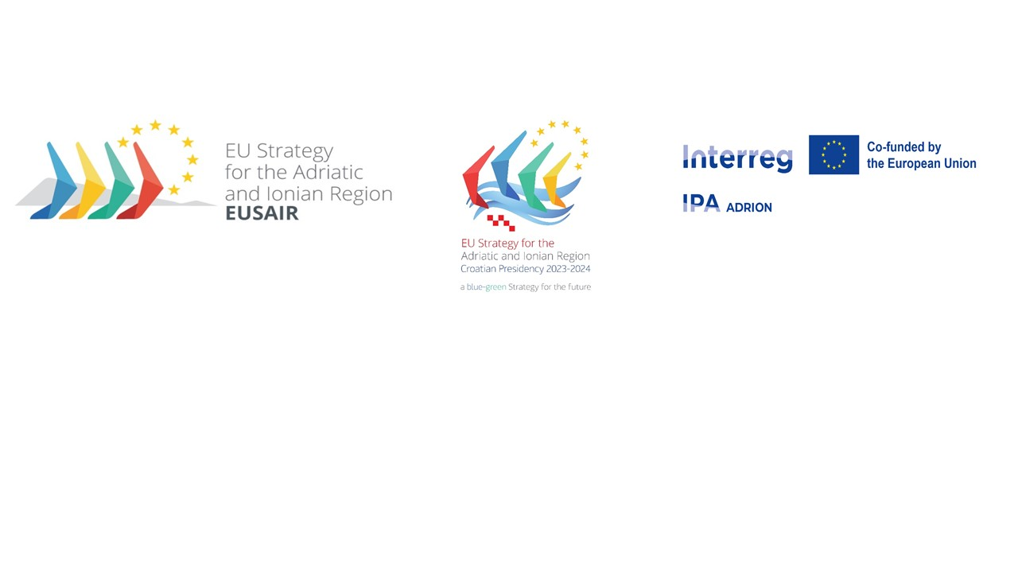
22nd GOVERNING BOARD MEETING of the
European Union Strategy for the Adriatic and Ionian Region (EUSAIR)
22 February 2024
Draft operational conclusions

Item 2  Adoption of the Agenda | - The meeting agenda was adopted.

Item 3  Approval of the minutes of the 21st EUSAR Governing Board meeting | - The minutes of the 21st EUSAIR Governing Board meeting with comments from Pillar 2 Transport Coordinator were formally approved.

Item 4  Presentation of the implementation of the Croatian EUSAIR Programme | - Governing Board was informed about the completed and planned events of the Croatian Presidency and about the concept and first programme of the 9th Annual Forum.  - A template for Pillar Sessions at the Forum will be sent latest until March 1st including the duration of the sessions, number of speakers whose travel and accommodation costs will be covered by the organisers and any possible guidance on the topics to be covered.

Item 5  EC input documents for revised EUSAIR Action Plan and Communication | - The Governing Board approved EC input documents for revised EUSAIR Action Plan and Communication with an exception of Pillar 2 Energy and indicators of Pillar 3.  - Comments received from DG ENER regarding natural gas and liquified natural gas in the EUSAIR Action Plan will be sent to National Coordinators and TSG 2 members. An online meeting will be organized between Pillar Coordinators of TSG 2 Energy, TSG members and EC (DG ENER and DG REGIO representatives). A proposal for revised section on Pillar 2 Energy in the Action Plan will be prepared by Pillar Coordinators and EC. After that a shortened written procedure (2 weeks) will be launched in TSG 2 and Governing Board for approval of the revised part of the Action Plan. This process needs to be finished by end of March 2024.  - A preliminary meeting between DG REGIO representatives, Pillar Coordinators and Italian TSG 3 members will be organized to agree on how explanation for Pillar 3 indicators will be prepared and on next steps. Based on the results of the meeting an explanation will be prepared and discussion within TSG 3 will be initiated. After agreement reached, a shortened written procedure (2 weeks) will be launched in TSG 3 and Governing Board for approval of the revised part of the Action Plan. This process needs to be finished by end of March 2024.  - Some comments resulting from the EC interservice consultation might arise and further revisions could be necessary. The comments received from Italy on 21 February will be addressed together with the comments from the EC interservice consultation. The Presidency and FP LP will keep National Coordinators informed. At the end of this process a Governing Board written procedure will be used to approve the final documents before the endorsement procedure.  - Governing Board approved Croatia and Bosnia and Herzegovina as Pillar Coordinators of Pillar 5 Improved Social Cohesion. With the today’s Governing Board approval of the Action Plan, all conditions for the start of regular work in TSG 5 are completed. Costs related to the support of regular work of Pillar 5 can be declared as of today.

Item 6  EUSAIR Governance Architecture paper | - The Presidency sequence will in principle follow the order of alternating EU Member State and EU candidate country, however the list will only be defined in the Governance Architecture Paper until 2027/2028. In 2026 this decision will have to be revisited to agree on the Presidency order for the next years. The order until 2028 is the following: Greece (2024/2025), North Macedonia (2025/2026), Italy (2026/2027) and Montenegro (2027/2028). The Facility Point budget will be revised accordingly.  - After Governing Board meeting a new version of the document will be circulated on 26 February including the above conclusion. A two week deadline (i.e. 11 March 2024) will be given to receive other comments on the Paper, after that no new comments could be sent. After consolidation of the final comments a Governing Board written procedure will be launched for final approval of the document.

Item 7  Establishment of EUSAIR Youth Council – update | - The Governing Board written procedure on approval of the EUSAIR Youth Council Concept paper was not successful.  - The Governing Board decided the EUSAIR Youth Council Concept paper needs further fine-tuning, all countries raising concerns are invited to send their comments to the paper until 6th March 2024 and take part in the next Task Force meeting scheduled for 26th March 2024 to prepare a revised Concept paper. Consolidated paper will be proposed for approval through a new Governing Board written procedure.  - Presidency invites all National Coordinators to coordinate with their Task Force members on the content of their contributions to the paper.  - The EUSAIR Youth Consultation Task Force will continue to supervise the process. Countries with no representatives in the Task Force are kindly invited to nominate them and to make sure necessary commitment is ensured.

Item 8  Presentation of the IPA ADRION programme - state of play | - EUSAIR Governing Board took note of the latest developments regarding IPA ADRION Programme.

Item 9  EUSAIR governance support projects | - EUSAIR Governing Board took note on the latest development in contracting of the projects and on the already existing services to EUSAIR governance structures and on tentative plan for the provision of services depending on the signature of Subsidy Contracts and Partnership Agreements.  - The use of the term EUSAIR Governance Point (EGP) to address the three governance support projects was agreed by the Governing Board.  - The Governing Board was informed about conclusions of the first meeting between Pillar Coordinators and EGP.  - A direct contact between Governing Board members, Pillar Coordinators and Lead Partners of the three governance projects should be established. Contacts of the Lead Partners and responsible IPA ADRION Project officer should be shared with the Governing Board members.

Item 10  Report from the Technical Meeting of Pillar Coordinators | - EUSAIR Governing Board was informed about latest and future activities of Thematic Steering Groups.  - New Pillar 4 Coordinator from Albania, Mr Elton Orozi, was introduced.  - Further discussion is needed on existing EUSAIR labelled projects and on the developed EUSAIR strategic projects/masterplans/actions. This discussion will be led by SP4EUSAIR project.

Item 11  AII: report on the meeting of the Committee of Senior Officials | - EUSAIR Governing Board was informed about AII activities.  - First draft of the Ministerial Declaration will be shared by the end of March 2024. During April, commenting and consolidation phases will take place. Final draft of the Declaration should be agreed at the NC/CSO level by May 1st 2024.

Item 12  A.O.B. | - The Governing Board agreed on the mandate for the start of work on post 2027 Cohesion Policy consultation in EUSAIR by the Croatian Presidency supported by EGP.

Item 13  Conclusions and next steps | - EUSAIR Governing Board chair concluded the meeting.

